CHAPTER FOUR — SYSTEM DESIGN
ADMAS University Attendance Management System
This chapter presents the system design of the ADMAS University Attendance Management System. It describes each screen of the system, its purpose, and the main functions available across all system roles — System Administrator, Head of Academic Affairs, Registration Office, Dean, Lecturer and Student. Interface mockups are provided for every module to illustrate the intended layout and user experience of the final implementation. Every screen includes a top header bar showing the university’s campus location, email and phone number.

4.1 Login Screen
The Login screen allows every system role to securely access the system using role-based credentials. A single "Role" selector lists all six roles, and each user is authenticated and redirected to the dashboard suited to their permissions.
- A single Role dropdown covering System Administrator, Head of Academic Affairs, Registration Office, Dean, Lecturer and Student.
- Username/Email and Password fields with secure authentication.
- Session validation and redirection based on the selected role.

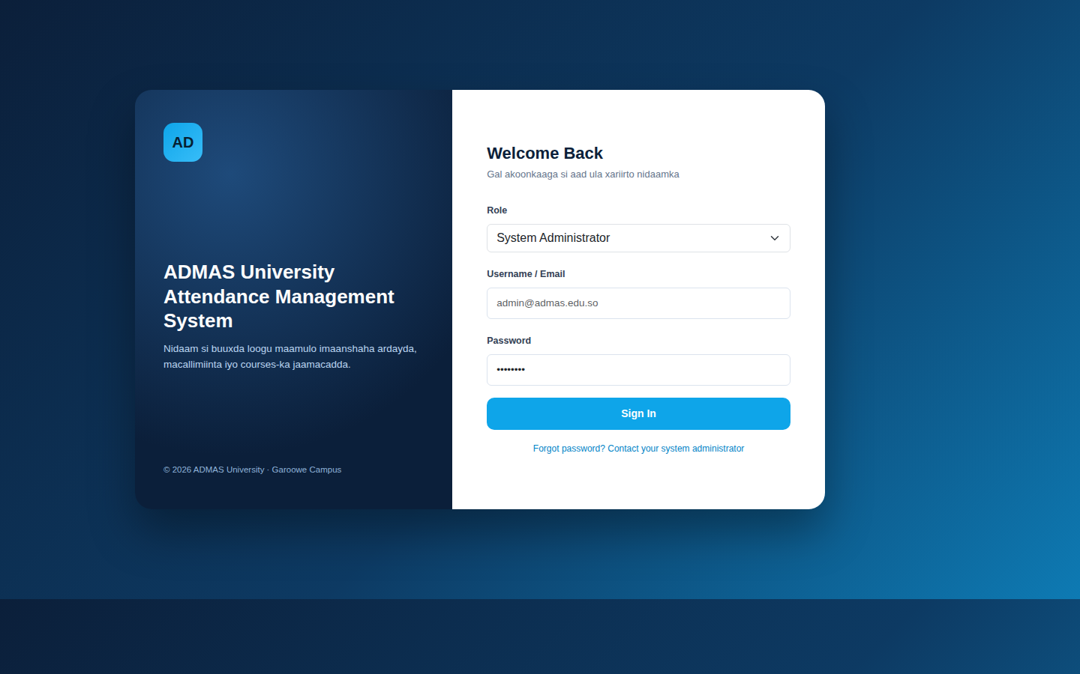
Figure 1: Login Screen

4.2 Dashboard
The Dashboard provides a system-wide summary immediately after login, giving the Admin a quick overview of key statistics and recent attendance activity.
- Total counts for Students, Lecturers and Active Courses.
- Average attendance percentage for the current day.
- Weekly attendance trend chart.
- Quick-view panel of students with low attendance, linked to the Notifications module (Section 4.13).

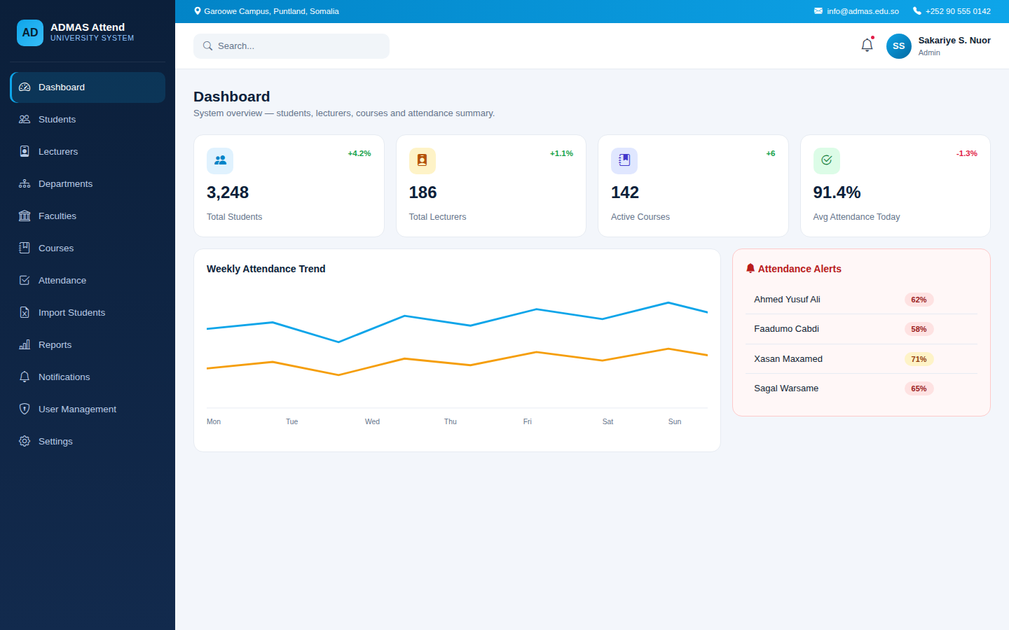
Figure 2: Admin Dashboard

4.3 Student Management
This module allows the Admin to manage all student records in the system. Student user accounts are created automatically once a student record is added.
- Add, edit, delete and search student records.
- Filter students by Academic Year, Faculty, Department, Level and Section.
- Each student record stores the Academic Year and Faculty the student belongs to.
- Automatic account creation linked to each student record.
- A dedicated "Import from Excel" shortcut opens the bulk import workflow described in Section 4.9.

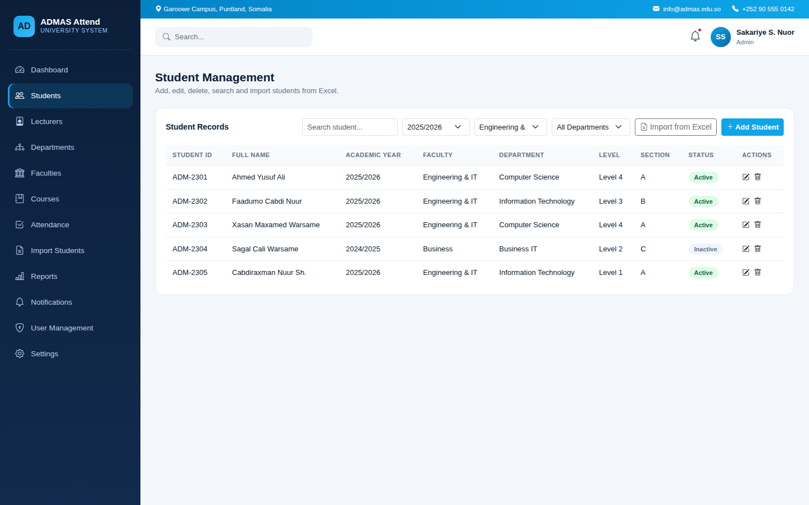
Figure 3: Student Management Screen

4.4 Lecturer Management
This module allows the Admin to manage lecturer records and the courses assigned to them. Lecturer accounts are also created automatically.
- Add, edit, delete and search lecturer records.
- Bulk register lecturers using the "Import from Excel" option.
- Automatic lecturer account creation.
- Overview of number of courses assigned per lecturer.

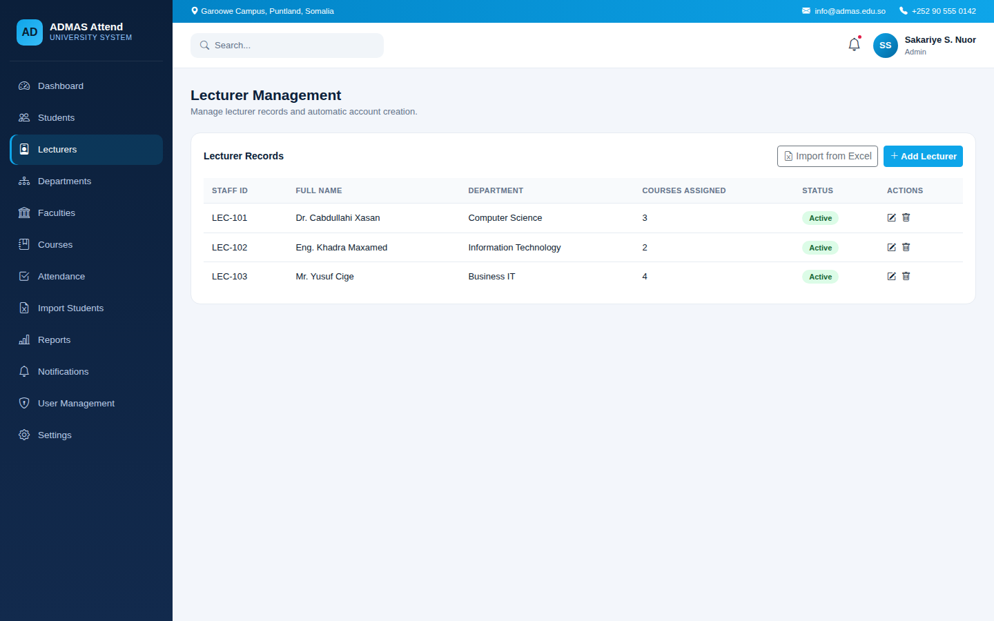
Figure 4: Lecturer Management Screen

4.5 Department Management
This module is used to create and manage the academic departments of the university, each of which is linked to a faculty.
- Create, edit and delete departments.
- Assign each department to a parent faculty.
- Bulk register departments using the "Import from Excel" option.
- View number of students registered under each department.

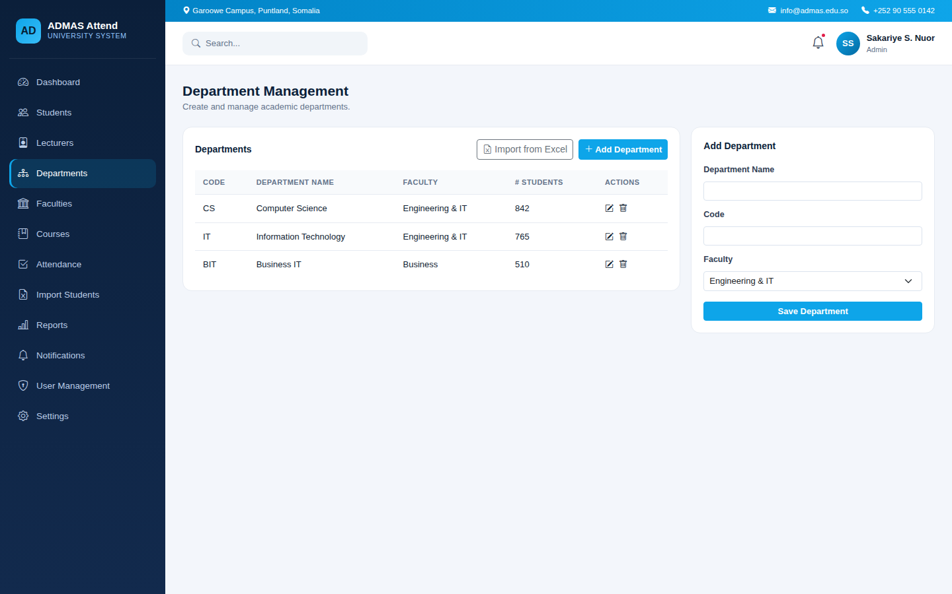
Figure 5: Department Management Screen

4.6 Faculty Management
This module allows the Admin to create and manage faculties, which group related departments together.
- Create, edit and delete faculties.
- Assign a Dean to each faculty.
- View the number of departments and students per faculty.

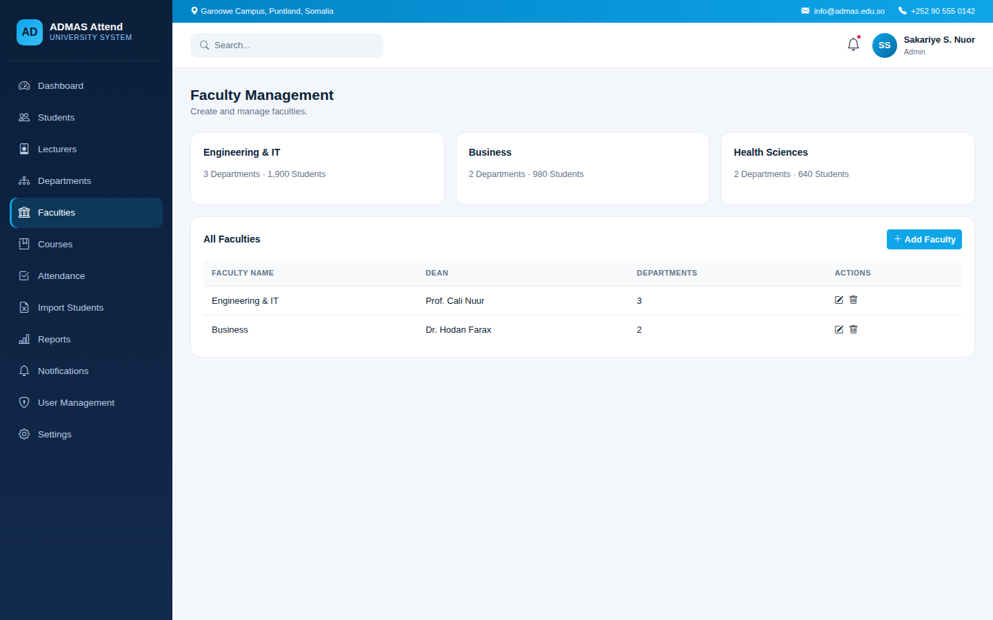
Figure 6: Faculty Management Screen

4.7 Course Management
This module manages the list of courses offered by the university and assigns each course to a responsible lecturer.
- Add, edit and delete course records.
- Assign a lecturer and department to each course.
- Define credit hours per course.

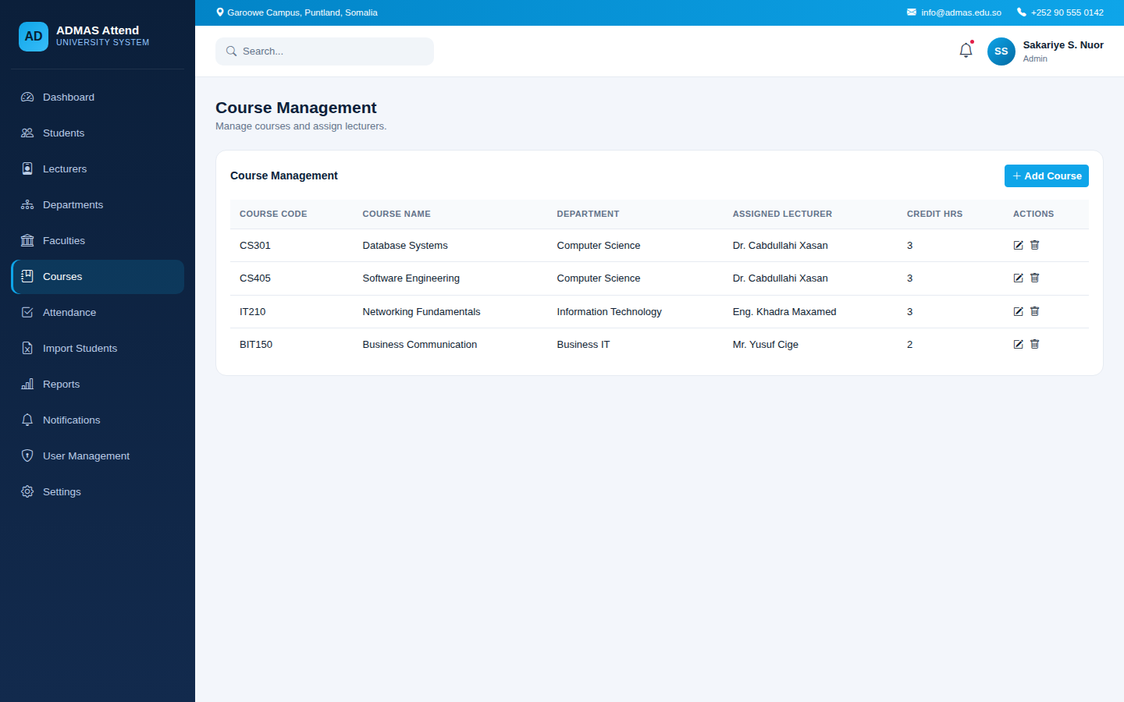
Figure 7: Course Management Screen

4.8 Attendance Screen
The Attendance screen is used by Lecturers to record student attendance for a selected Academic Year, Faculty, Course, Shift and Date, ensuring each attendance record is correctly scoped even when a lecturer teaches the same course across multiple years, faculties or shifts.
- Select Academic Year, Faculty, Course, Shift and Date before loading the student list.
- Shift options are Morning Shift, Afternoon Shift and Weekend, matching how ADMAS University organizes its class timings.
- Mark each student as Present, Absent, Late or Excused.
- Save attendance records for later reporting and analysis.

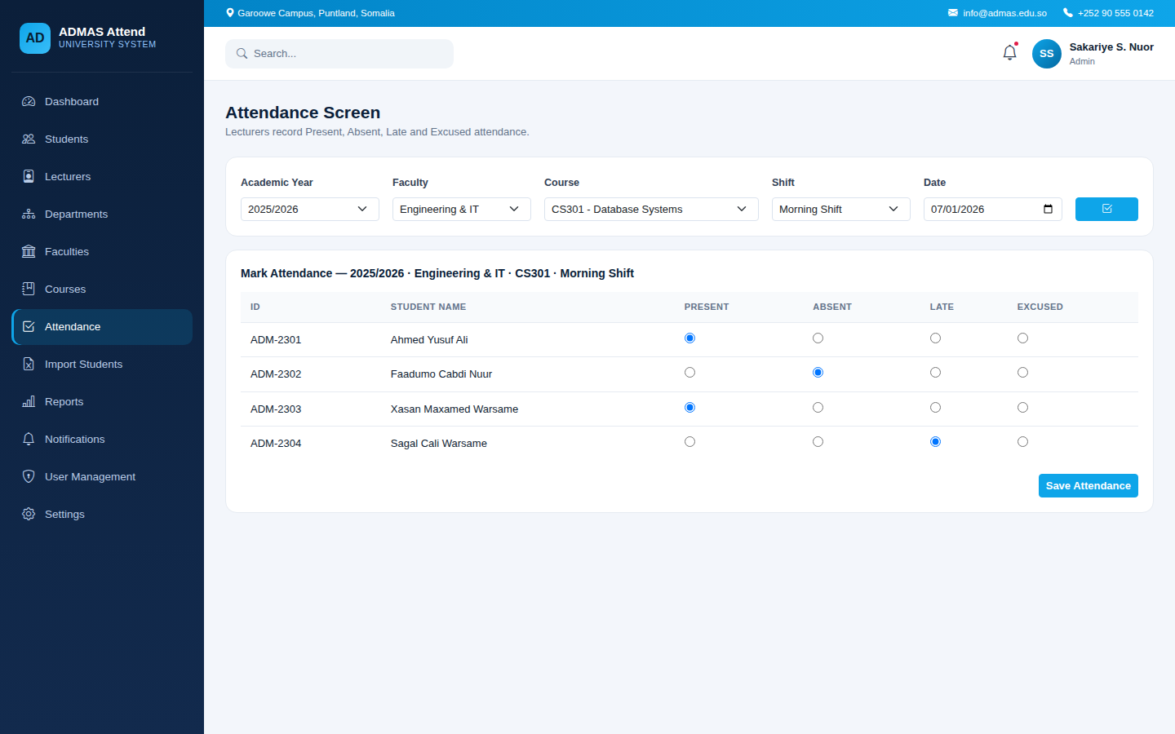
Figure 8: Attendance Marking Screen

4.9 Import Students from Excel
This module allows the Admin to bulk-register students by importing an Excel file, reducing manual data entry.
- Select Academic Year, Semester, Faculty, Department, Level and Section before import.
- Upload an Excel file containing student details.
- Preview imported rows and flag missing or invalid data before final confirmation.

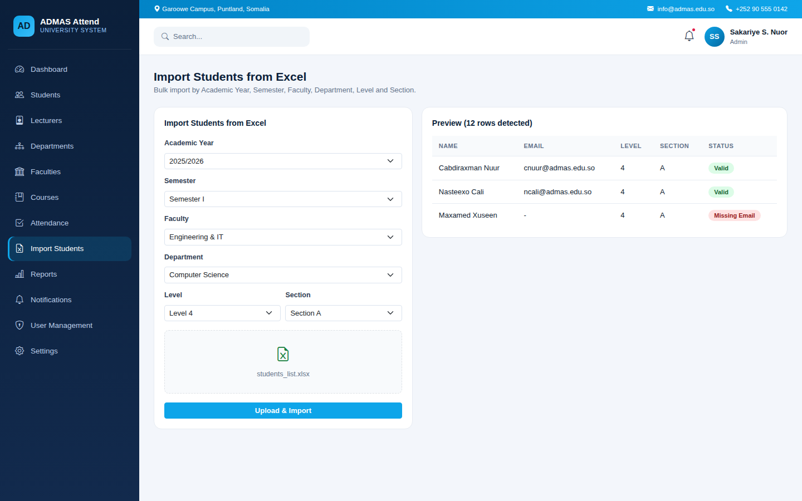
Figure 9: Import Students from Excel Screen

4.10 Reports
The Reports module generates attendance reports that can be filtered and exported for record-keeping and analysis.
- Generate reports by course, department or date range.
- View average present/absent percentages per course.
- Export reports to PDF or Excel format.

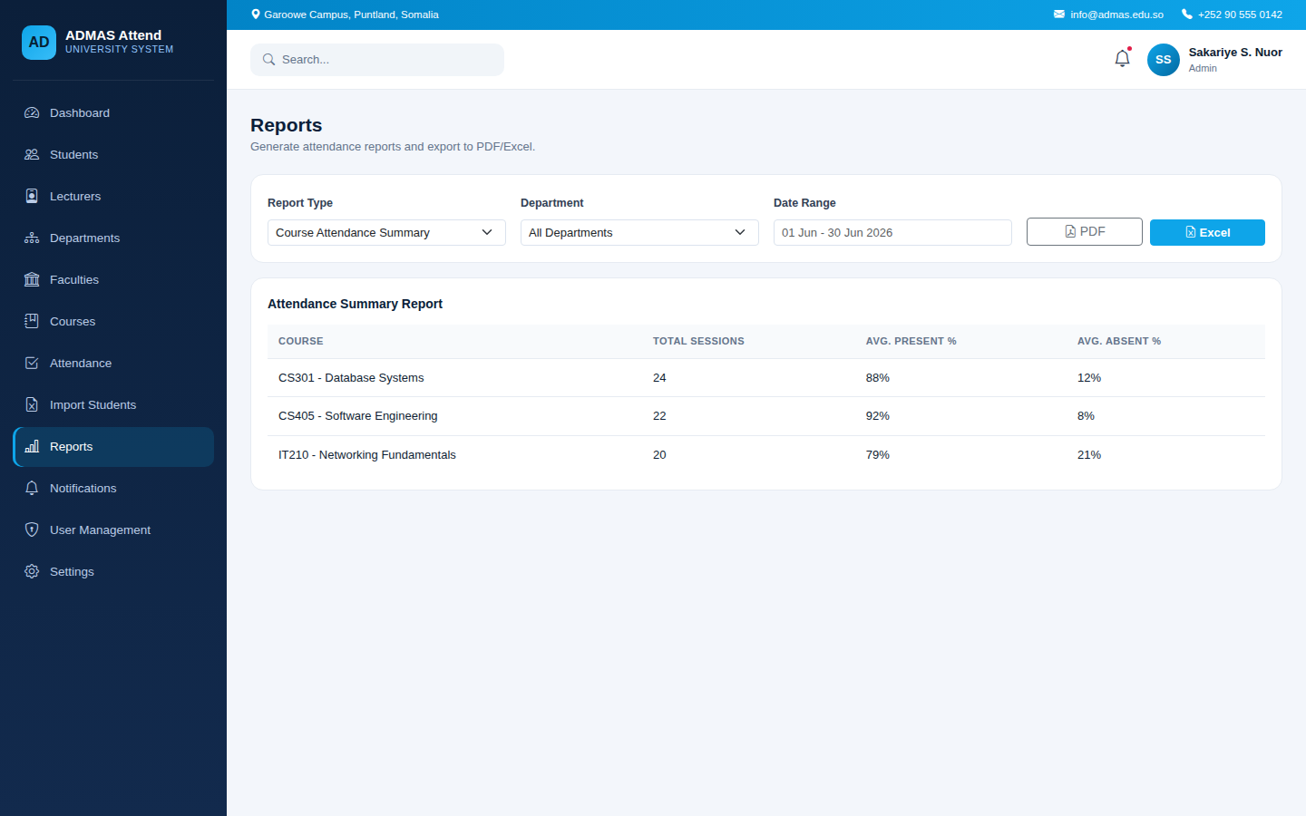
Figure 10: Attendance Reports Screen

4.11 User Management
This module allows the System Administrator to manage all system user accounts across all roles, and to appoint users into the three delegated administrative roles: Dean, Head of Academic Affairs and Registration Office.
- System Roles & Responsibilities panel summarizing what each role is scoped to manage (see table below).
- Assign Role panel: select a user, appoint them as Dean, Head of Academic Affairs or Registration Office, and — for Dean specifically — select which single Faculty they will oversee.
- View all users with their role, status and last login.
- Reset user passwords and activate/deactivate accounts.

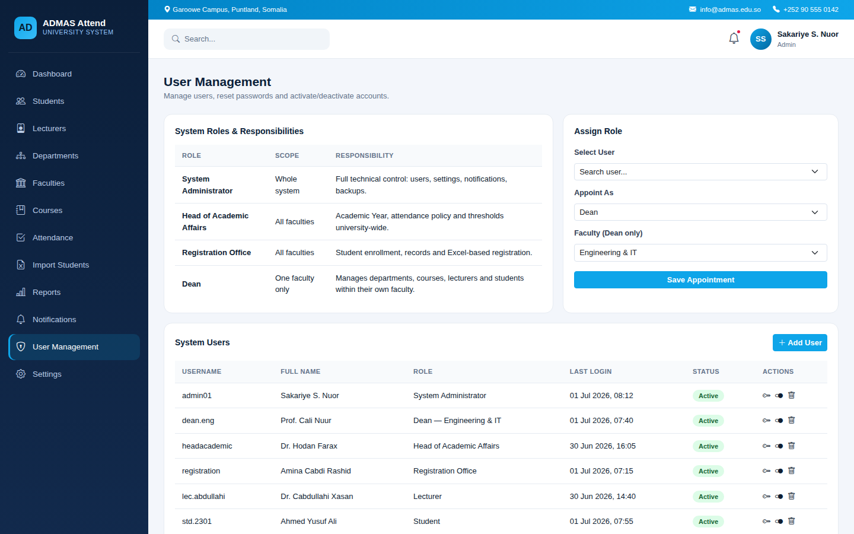
Figure 11: User Management Screen

System Roles Summary
Role | Scope | Responsibility
System Administrator | Whole system | Full technical control: user accounts, system settings, notification thresholds, backups. A technical (ICT) role, not an academic decision-maker.
Head of Academic Affairs | All faculties | Sets university-wide academic policy: Academic Year configuration and the minimum attendance threshold used for alerts.
Registration Office | All faculties | Handles student enrollment: adding and importing student records across all faculties.
Dean | One faculty only | Manages departments, courses, lecturers and students within their own faculty only; cannot view or edit other faculties.

4.12 Settings
The Settings module allows the Admin to configure general university information and default academic scope used throughout the system.
- Configure university name, campus and contact information.
- Set the current Academic Year, along with the default Faculty and Department scope used across reporting and filtering screens.
- Define the minimum attendance percentage threshold used for alerts.

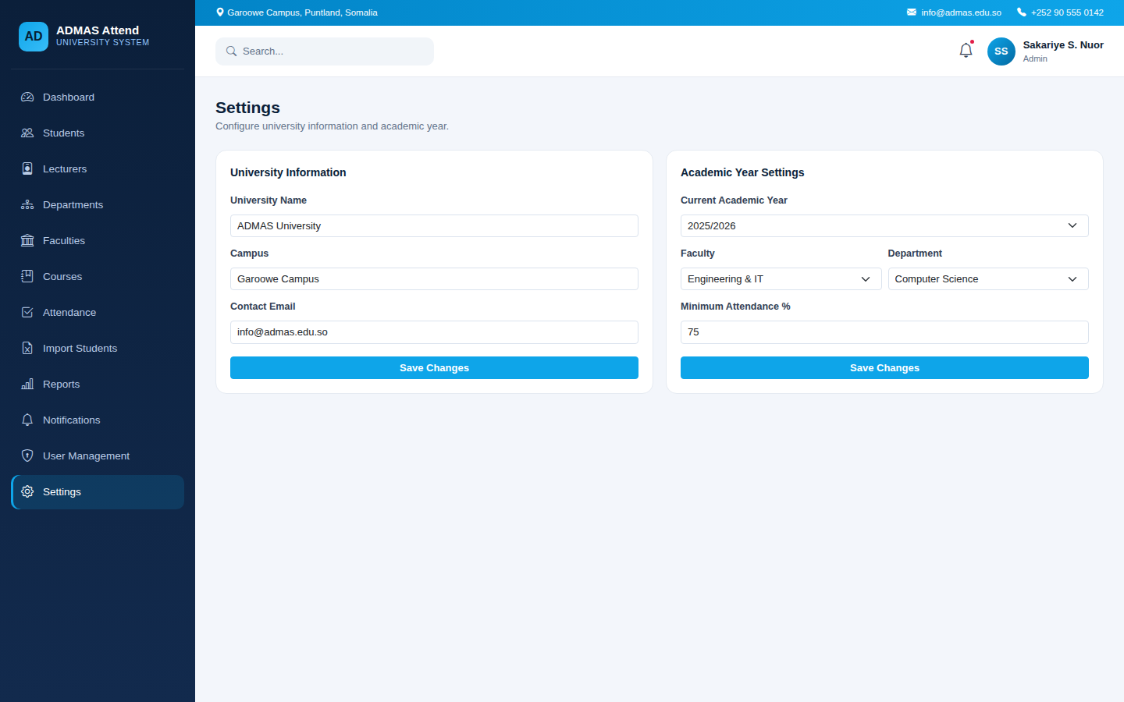
Figure 12: Settings Screen

4.13 Notifications and Alerts
This module was added to strengthen the early-warning capability of the system. It automatically monitors student attendance percentages and raises an in-app alert whenever a student falls below the configured minimum attendance threshold, allowing the Admin and Department Heads to intervene before the situation affects the student’s academic standing.
- Automatic calculation of each student’s attendance percentage per course.
- Configurable alert threshold (default: 75%), managed from the Settings panel within this module.
- In-app alert list showing affected students, their course and current attendance percentage.
- Alert recipients are configurable: Admin Dashboard, Department Head, and optionally the Student’s own portal.
- A summary of unread alerts and total at-risk students is also shown on the main Dashboard (Section 4.2).

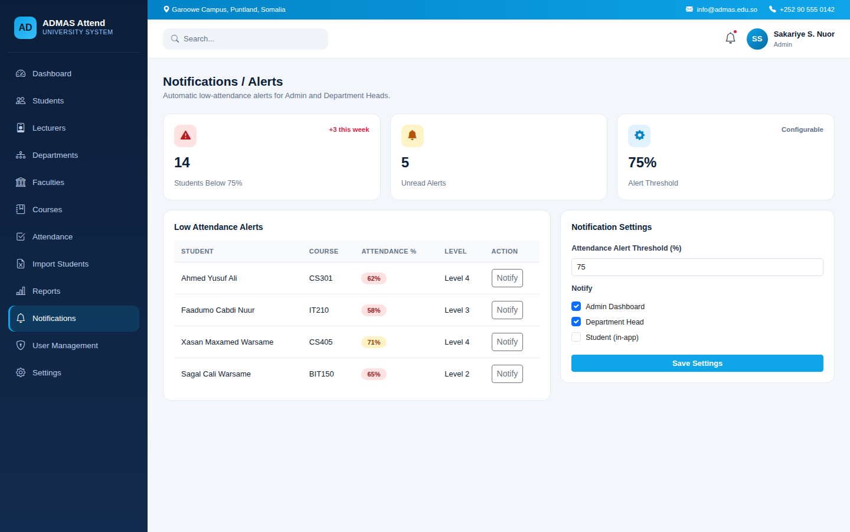
Figure 13: Notifications / Alerts Screen
Note: to keep the scope of the current system manageable, this module is implemented as an in-application notification feature only. External channels such as Email or SMS delivery are proposed as future enhancements in Chapter Five, since they require additional third-party integration (e.g. SMTP or SMS gateway configuration) beyond the core scope of this project.

Role-Based Dashboards
In addition to the Admin modules described above, the system provides tailored dashboards for the Student and Lecturer roles, giving each user access only to the features relevant to their responsibilities.

Student User
The Student can view personal attendance records, overall attendance percentage, enrolled courses, profile information, and can change their password.
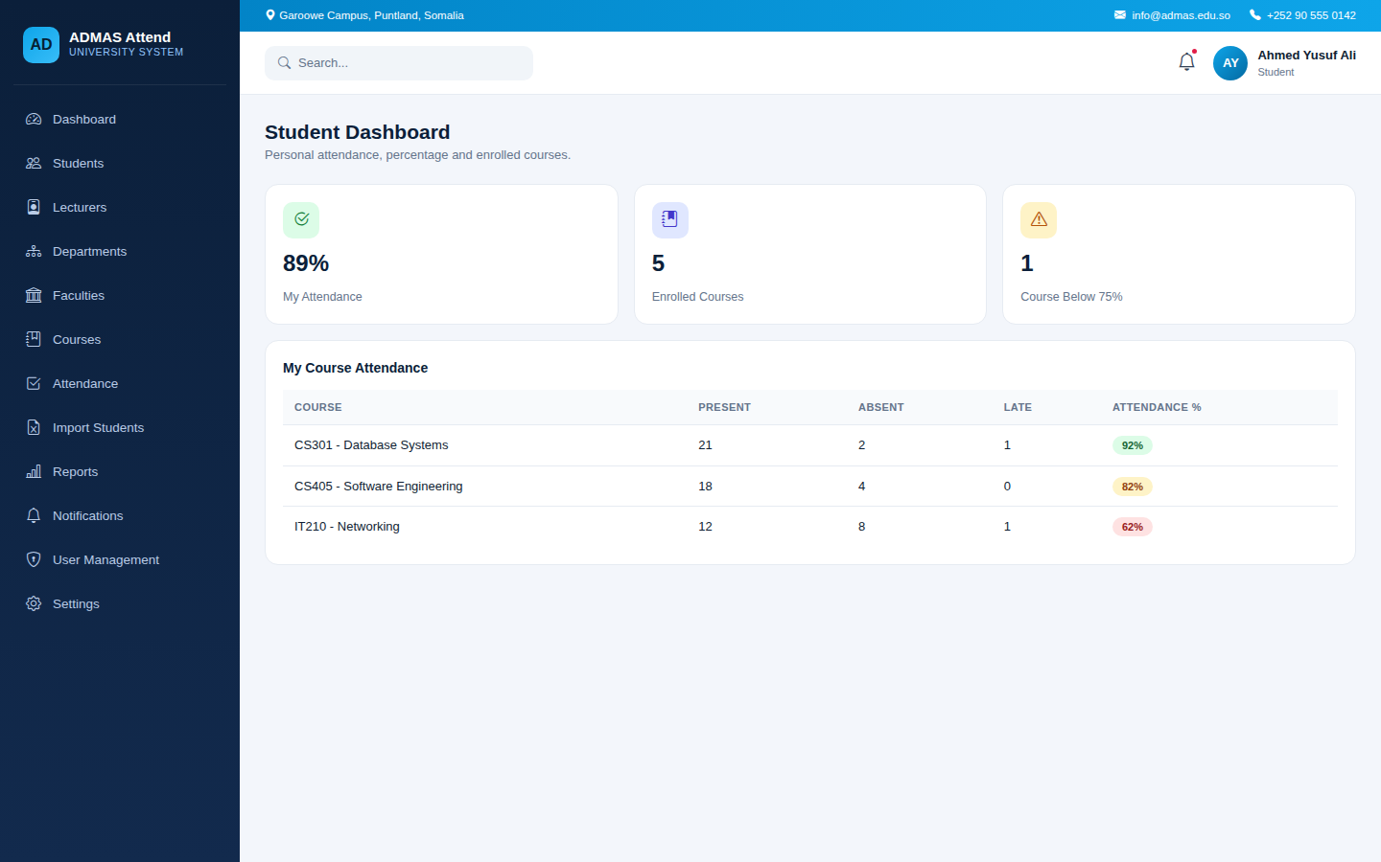
Figure 14: Student Dashboard

Lecturer User
The Lecturer can take attendance for assigned courses, view a list of assigned courses, generate class-level attendance reports, and update their profile and password.
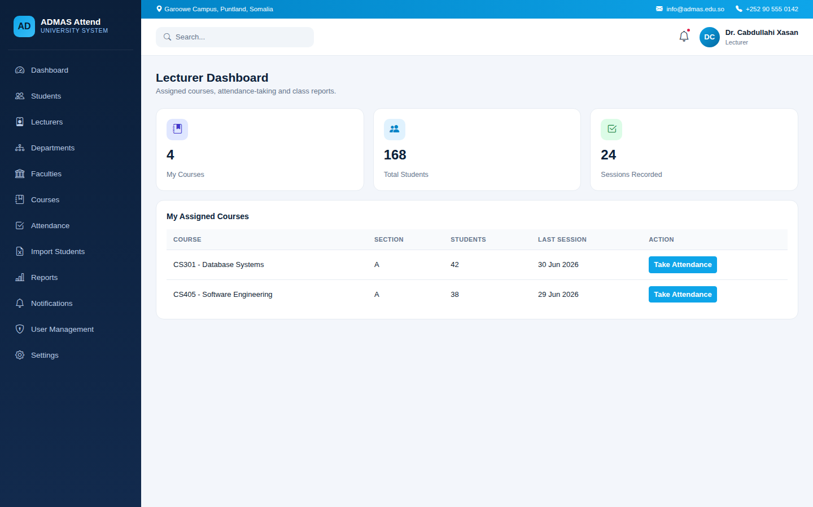
Figure 15: Lecturer Dashboard

